**ARE native speakers THe only model for ELF users?**

AUTHOR AUTHOR

INSTITUTION

email

1. **Introduction**

In this paper, we will discuss results of a survey of learners of English asked to listen to recordings of various speakers (mostly well-known non-native speakers) and compare the marks that they give these with those they give to native speakers (NSs). Previous questionnaire-based research conducted by us[1] shows that learners voice conflicting opinions on matters related to the nativeness principle: the idea that learners should emulate NSs to speak a language well. This leads one to believe that there is certainly potential for learners to move away from traditional approaches that put the idealised NS and their supposed models at the centre of teaching and to adopt instead approaches more oriented towards ELF (English as lingua franca). By simply asking respondents to listen to and grade recordings on a Likert scale, we are able to observe from another perspective their unguarded attitudes to both NS and NNS. The hypothesis is that if they can be shown to be similarly well-disposed to some NNSs as they are to NS then there is reason to believe that, as users of English in a world where it has become a translocal language[2] (see Pennycook 2007 and Blommaert 2010), and as methodologies like Content and Language Integrated Learning (CLIL) which put the emphasis on treating students as users rather than learners gain ground in English Language Teaching (ELT),[3] learners are developing attitudes that are in tune with the idea that ELF (English as Lingua Franca) variations should be acknowledged and tolerated within ELT as an alternative to the nativeness principle in recognition of the fact that variability as a necessary and inevitable feature of natural language use.

In the following sections, before discussing the research itself in Sections 4.0 and 5.0, we shall first look at the shortcomings of the traditional nativeness principle and the promotion of NS models in ELT (2.0) before discussing some of the difficulties to finding alternatives to them (3.0).

1. **Models: how relevant are they?**

Traditionally, in language acquisition and assessment, emulation of the “ideal native speaker” has been the guiding principle and remains to this day pervasive. This is seen in the *Common European Framework of Reference for Languages: Learning, Teaching, Assessment* (CEFR - Council of Europe: 2001)[4] where it employs the concept of NS as a central point of reference in its scales and aspects of performance associated with NNSs indicate lower levels of performance, for example:

1) Pronunciation is clearly intelligible even if a foreign accent is sometimes evident and occasional mispronunciations occur.

(Descriptor for B1 band, Phonological Control, p. 117)

Even if English were not an international lingua franca and one at that where NSs account for the minority of users (Kachru 1985), those who accept the conventional wisdom that the NS must forever reign supreme would be hard-pressed to describe what exactly an ideal native speaker would (or *should* for those of a prescriptionist persuasion) sound like. In the case of English, where happily, for linguists of a scientific and descriptivist bent, no central official authority, like the *Académie Française* does for French, exists to adjudicate on such matters. Indeed, many different models or models exist within Kachru’s (1985) inner circle countries and have emerged also in the outer circle (mostly ex-British colonies where English is used as a functionally native second language – see Kachru 2005). The very idea of model, often called “standard” when it comes to represent the variety considered superior to all others, is in itself a badge of social prestige, not of linguistic superiority or intrinsic linguistic fitness to be emulated.

In her appropriately entitled chapter “Standard English and real English”, Seidlhofer (2011) notes how conventional wisdom within ELT is that it is the NES alone who is the authoritative arbiter of Standard English. This variety is unique in that it is conceived as having a static and homogeneous nature, while Seidlhofer points out that it is, for reasons we shall look at in this section, “elusive of deﬁnition” (2011: 71).[5] In her view, visions of English based on a contrast between standard and non-standard, where the former is seen as something static and the latter as something detrimental to the preservation of norms (cf. Quirk 1985), fail to take into account the inherent dynamic intelligibility of language used naturally for communication especially between people of diverse linguacultural backgrounds. As she says (2011: 48) such a view ignores “the encoding potential of English being used variably and without institutional sanction across communities and cultures.” [6]

To take a historical perspective on advocacy of the need for static standards, certain varieties have always been considered inferior to others and those using them denigrated. This principle has been extended to speakers using such languages and varieties. This last fact is particularly ironic in the case of the world’s most “successful” languages (in terms of the numbers of people who speak them) such as English, Chinese and Spanish; according to McWhorter (2007), in their expansion, they came to be acquired by many adult speakers as L2s, which contributed greatly to how they subsequently evolved[7] – in particular in the way that they came to be simplified compared to their older forms when they were spoken by smaller communities of exclusively NSs.[8]

As regards pronunciation in particular, and for obvious reasons this is what people tend to notice first about how another person speaks, the two most often cited models for both native and non-native speakers are *Received Pronunciation* (RP)[9] for British English and *General American* (GA or GenAm) for US English. Someone using either of these two models would be expected to use standard grammar and lexis as well, although this point is often left implicit. It would be highly unusual to hear someone using regionalisms or non-standard forms such as “Go ‘ed, lad, get us an ale in”; or “I bin layin' here long time thinkin' de straight uv hit”, in an RP or GA accent (unless it was for comic effect)[10]. Both RP and GM are supposedly regionally or ethnically neutral, even if in both cases they can in practice be associated with the “better educated” and thus the “higher” echelons of society (and those ethnic groups most likely to reach them). Both are largely amalgamations of the historically more widespread or prestigious varieties and owe their adoption largely to the advent of radio and telecommunications, where standardised pronunciation on the air was once deemed necessary in the same way that standardised spelling is considered expedient in print.

In the UK, where US-style commercial broadcasting was not originally widespread,[11] RP become largely synonymous with *BBC English*,[12] which fell under the control of the notoriously paternalistic John Reith. This led to RP developing a much more upper-class flavour than did GA, which reflects more the US middle class of the area encompassing the West, Western New England and North Midland regions (Van Riper 2014: 129–130). Consequently, GA continues to represent more closely the way that many Americans speak,[13] even though some non-standard varieties such as African American Vernacular English (AAVE) enjoy a high profile nationally and internationally.[14]

By contrast, RP has become increasingly irrelevant in the UK and in broadcasting. Already in the 1940s, the BBC allowed more non-standard varieties onto the air as they often proved more popular with the audience and had in any case always been deemed appropriate for certain genres such as local news, sport, drama or comedy. As a consequence, today, someone with a genuine RP in broadcasting in the UK is a relative rarity.[15] In recent decades, the dialect of the South East, so-called Estuary English, apparently partly an evolution of London’s Cockney, has gained ground and prestige and has been seen by some as a possible future alternative to RP (see Rosewarne 1994). Others, working as part of a British Library project,[16] argue that RP has evolved into three categories: *conservative*; *mainstream;* and *contemporary,* which is just to say that, like any other living variety, it is constantly changing over time.[17] On the whole, it can be said that, as in the USA, a kind of general pronunciation has emerged where speakers avoid features that are too specific to their own regional variety or sociolect when speaking with those not familiar with them.[18] However, the result is less homogenous because of the fact that within the UK, with its much longer history of using English, there exist many more regional varieties and there are greater differences between them even if the distances that separate them are by US standards minimal (compare for example: Glaswegian with Embra from Edinbruugh; Mancunian from Manchester with Scouse from Liverpool; or Brummie from Birmingham with the East Midland dialect and its subvarieties spoken in such places as Leicester, Derby or Nottingham).

A proponent of models may argue that the more homogenous US GA model would avoid most of the problems associated with the more heterogeneous British varieties and the dating RP. They may even propose the promotion of what, for example, Crystal (2003: 185) dubs a “World Standard Spoken English” perhaps taking its cue from the *Mid-* or *Trans- Atlantic* varieties[19] and other similar amalgams that have emerged.

However, debates over which model to use miss the point about whether standards are necessary at all. The tens (if not hundreds) of thousands of years in which languages have existed shows that models, at least of the formalised prescribed kind, are not vital for a language’s survival or evolution. Indeed, they are relatively modern inventions. No language system in the real world is perfectly fixed and stable in that, even among monolingual NSs, it consists of a set of constructions in the mind of each individual native speaker (idiolect) and these may differ in subtle ways; ELF is particularly mutable and fluid in that the speakers will each come with their own lingua-cultural background and will typically adapt and accommodate their way of speaking to that of the other participants. It thus takes the form of improvised instantiations which are constantly changing and adapting, tailored to the needs of the specific discourse context and to the other participants engaged in it*.* As Widdowson (2015) states, the emphasis of ELF is not the *variety* of a homogenous speech community but of the *variations*[20] that spontaneously emerge when members of different communities meet and go about the task of communicating:

(…) what is clearly evident in the use of ELF is that communicative capability not only does not depend on conformity to Standard English norms – it does not depend on conformity to the norms of any other variety either. And here, too, is the essential distinction between ELF and WE [World Englishes]. The study of ELF considers variability not in terms of variety at all but as the variable use of English as inter-community communication, as communication across communities. Widdowson (2015: 362)

Standards, NS or otherwise, are less relevant to learners today because English has become the international lingua franca increasingly between non-native English speakers (NNESs): the very situations where an ELF approach is more appropriate. This is a fact which obviously presents new challenges for educators and policy makers, and paradoxically here lies one possible reason for the continued attractiveness of the nativeness principle: it propagates a reassuring illusion of stability in a rapidly changing and increasingly confusing world.

Furthermore, on grounds of equality, it is difficult to justify the fact that NNESs are automatically expected to adopt standards based on idealised native English speakers (NESs) in situations where ELF variation is being employed. In such contexts, most if not all of the participants will be NNES, and the speech event that they collectively contribute to must be judged on its own merits, not seen solely as an imperfect copy of what NESs would produce in the same situation.[21] On a methodological level, comparison of what NNES *actually* produced with what an ideal NES *might* have produced is a blinkered and unsound way of proceeding, not least because each speech event is, as the philosopher Benedetto Croce famously pointed out, unique and unrepeatable, and meaning is inextricable from context of use (see Author 2015: 89).

The equality issue also raises all-important questions of the user being able to determine and preserve their own identity (Jenkins 2007). Advocates of an alternative ELF-oriented approach to ELT would argue that participants should have equal rights to negotiate the norms for pronunciation on the basis of the demands of communicating efficaciously and achieving the goals that they have set for themselves in the given situation. A major drawback with the nativeness principle is that emulation has its price: that of obscuring one’s own origins – typically a major element of one’s identity. It can be interpreted as a denial of one’s primary community values (Guido 2008). It is up to users to decide whether or not they want to conceal their own identity and lingua-cultural background by adopting an anonymous globalised English standard voice of some sort, much as forcing speakers of non-standard varieties to adopt a standard is now frowned upon. Even if the emulation is successful (which only happens in a minority of cases), those using the one-size-fits-all standard can seem affected and devoid of personality or individuality.[22]

The issue of equal rights with NESs is also one that has animated speakers of varieties of English from the outer circle: “beyond the canon” to cite the subtitle of Kachru’s work on Asian Englishes (2005). In this way, an approach to language teaching that views learners as users can be seen as a logical extension of the process by which L2 English speakers from the outer circle gain equal status with L1 speakers and serve as models for other L2 speakers. Of course, with EFL users, the issue of proficiency becomes an important concern when determining what may constitute a model, as it does to some extent for speakers from both the outer and inner circles. This aspect is covered in Graddol’s (2010: 110) reworking of Kachru’s original model which has the inner circle not occupied by native speakers but by “highly proficient users”, with progressively less proficient ones moving out from the centre. However in EFL contexts, as with outer circle varieties of English, proficiency will be measured not against a scale designed around progressive emulation of an idealised inner circle speaker but on the basis of being able to successfully communicate in the specific context of use.[23]

1. **Alternatives to the nativeness principle.**

It has been argued that a *principle of intelligibility* should replace that of nativeness in ELT. This concept has been promoted by people such as Levis (2005) who associate it mainly with pronunciation but in the specific context of ELF, we can extend it to all levels of language including lexis, morpohology and syntax. In essence, those advocating for a principle of intelligibility to replace the nativeness principle argue that many features of NES language use will always be difficult for most NNESs to replicate and thus the utility of learning to master certain features, such as difficult phonemes, phrasal verbs, or question tags, may not merit the effort required to master them when simpler equally effective alternatives can be naturally invented or created by the users themselves in the normal process of spontaneously communicating in the language.[24] NNESs should instead focus on producing language that is clear and unambiguous in the context of the speech event they are involved in and the participants with whom they are communicating even if at times it strays from the kind typically produced by NESs.

What such renegotiation of English would entail depends on the precise context and the lingua-cultural backgrounds of the participants and the ways in which they can accommodate to each other. In the specific context of pronunciation, Jenkins (1998, 2000) identifies a *Lingua Franca Core* (LFC), which consists of key areas crucial for intelligibility (e.g. most, but not all consonant sounds; vowel length distinctions; nuclear stress), that may be used as a template for the teaching of pronunciation to NNESs. In particular, it leaves out word stress or tone, which are often a focus of traditional ELT.

The concern is that the LFC (or other alternatives which might be proposed) may be dismissed by learners, educators or policy makers as inferior forms of simplified or “broken” English. Furthermore, while the nativeness principle involves emulation – a simple enough concept for most people to grasp quickly (even though, as we see above, in practice it presents other problems) – the intelligibility principle entails a subtle change in attitude and the adoption of a particular set of strategies, such as accommodation (Giles et al 1991), and translanguaging (García / Wei, 2014) that need to be adapted to specific circumstances. In short, it does not in itself offer a clearly identifiable universal template.

That said, the forces working in favour of ELF and a greater recognition of its implications in the classroom are also working inexorably against the nativeness principle. For one thing, as we say in Section 1, English has become a *translocal* language, and learners, especially millennials born after the 1980s, are also habitually using it outside the classroom, not least on social media and the internet. What this means is that, analogously to the way that they have become digital natives, people are increasingly becoming ELF natives because it has become familiar to them at an early age. Such a user may feel a closer affinity with other NNESs using ELF variations in similar conditions than with NESs. One may consequently envisage a situation where ELF users provide models for other ELF users. It is in such contexts that things like the intelligibility principle and the LFC may become actual phenomena, rather than abstract ideas, which thus may be observed and emulated.

Determining how far such a process is under way is the object of our analysis of the survey of learners’ reactions to different users of English (NES and NNES) which we report in the following section (3.0). In doing so, we will draw on similar research (Author 2011a) that, among other things, showed that respondents are not very reliable at identifying recordings of NES from among NNES (thus casting doubt on the proposition that learners really do emulate NESs). Furthermore, it was noted that the speaker who most respondents erroneously identified as a NES was also the one that they had marked most highly for pronunciation and intelligibility. Similarly, it was also apparent that if a respondent identified a given speaker as a NES, then they were more likely to give them higher marks for pronunciation and intelligibility. This leads one to suspect that the notion of NES is indeed conflated with something like Graddol’s (2010: 110) concept of highly proficient user who, he argues, may occupy the inner circle of Kachru’s three circles model (1985) regardless of whether they are NES or not.

In this present research, we investigate whether ELF users could provide models by examining other ELF users’ reactions to recordings of them, comparing the scores they give when they are told that certain speakers are NES or NNES. For our NNESs, we use subjects who enjoy a level of prestige in their respective fields (e.g. the singer-songwriter and record producer Shakira or martial arts expert, actor, film director and producer Jackie Chan) in recognition of the fact that linguistic and social prestige are closely related:[25] i.e. if such figures may be role models in other ways, they may also conceivably become role models for language use. There are plenty of precedents for people consciously or unconsciously starting to incorporate non-standard features into their own language. For instance, in the period of Beatlemania, the Scouse dialect of the “Fab Four” (or vague approximations of it) became all the rage among aspirant rock stars and celebrities hoping to join the British “invasion” of America. Why such emulation occurs is one of the central issues in our discussion in this paper question and depends not so much on concerns of communication but on the desire to identify oneself with a certain type of speaker. Obviously the nativeness principle depends on users identifying with NSs and wanting to emulate them.

As regards non-standard features, the process by which innovation leads to variations which in turn can if, repeated enough, become new varieties is identified by Widdowson (2015) and are essentially the very same process by which much structural linguistic change comes about. For example, many terms in GA, derive originally from AAVE, which became fashionable in the jazz age and afterwards. As Widdowson (2015: 360) points out: “Innovation can, of course, be inspiring and there will always be the tendency for people to be influenced by ideas in vogue.”

In the light of this discussion of emulation and adoption of non-standard features and the transition from variations to varieties, it is interesting to note the advent of Multicultural London English (MLE) -- see Cheshire *et al* 2014. This is often popularly dismissed as *Jafaican* (a blend of *Jamaican* and *fake*) in the belief that it is merely an attempt, in particular on the part of urban White youths, to copy the speech of their Black peers: e.g. Sacha Baron Cohen’s comedy character Ali G. According to Cheshire *et al* (2014), MLE is not simply emulation but a new variety in its own right (and they describe similar *multiethnolects* in other North European cities). It is instead a kind of amalgam of the NS London Cockney or Estuary English varieties with features taken from other varieties of English spoken by ethnic minorities with a heritage in the outer circle (e.g. Jamaican English or Nigerian Pidgin) or from ethnic communities originating in the outer or expanding circles using completely different languages (particularly those from South Asia and West Africa such as Hindi, Bengali, Yoruba or Hausa).[26] MLE is significant in the context of the nativeness principle as it shows that not only can NNSs provide a model for other NNSs, but that they can also provide one for NSs too.

1. **Survey: profile of respondents**

The survey that we conducted was hosted on a Moodle hosting service.[27] It was aimed at respondents at B1 level and above on the CEFR who were recruited in various ways: from those who had completed the questionnaire reported in Author (2017); through the Università del Salento (Italy) Moodle platform; through colleagues at other universities in Turkey and Poland, and in state schools in Italy, Germany and at private language schools in Albania.[28] Unavoidably, respondents had to register on the system and leave an email to receive an activation key, which was an added inconvenience that probably discouraged some.

Sixty-one learners completed the survey. Judging by the first names,[29] 48 (78.69%)[30] were female and 13 (21.31%) male. We did not ask respondents for detailed information about themselves as we wanted to make the survey as quick and user-friendly as possible and wished to avoid a lengthy registering process.

**5.0 Survey: methodology**

Each respondent listened to five short recordings (all approximately 60 seconds) of NNES ELF users and one NES speaker. The five NNES were taken from You Tube and converted to audio files.[31] The NES was recorded by us. All of the speaker’s origins were clearly identified. We also gave some limited information about their background and the topic of the extract. Below are the instructions relative to each extract (Figure 1):

1. Listen to this recording of the film director and actor Jackie Chan, from Hong Kong, talking about film-making:

2. Listen to this recording of Queen Rania of Jordan talking about online education:

3. Listen to this recording of the singer and songwriter Shakira, from Colombia, talking about young people and activism:

4. Listen to this recording of the singer and songwriter, Youssou N'Dour, from Senegal, talking about his political ambitions:

5a Listen to this recording of Kevin, an English teacher from London, talking about his ideal friend:

5b Listen to this recording of Alfonz, an English teacher from Slovenia, talking about his ideal friend:

6a Listen to this recording of Donald Tusk, the President of the European Council and former Prime Minister of Poland, talking about Europe:

6b Listen to this recording of a Member of the European Parliament, Stuart McKinlay from Scotland, talking about Europe:

6c Listen to this recording of Jack, an unemployed man from Manchester, talking about jobs that he used to do

6d Listen to this recording of Jerzy, a Polish migrant who lives in Manchester, talking about jobs that he has had:

Fig. 1

Speaker-specific listening instructions and background information

As can be seen, we did not make the distinction between NES and NNES explicit because we did not want to alert respondents to our object and thereby risk respondent bias. The background information, as well as the names chosen in those cases where the intention was to mislead, are intended to imply whether the speaker is NES or not.

Only Speaker 5a (the NES – name changed for reasons of privacy) was not a famous person, but his name, Kevin, and the way he is described, identifies him as a NES. While this speaker does not have an RP accent as such, he did not use any non-standard lexical or grammatical forms. He is an experienced EFL teacher, originally from London, and speaks with some unobtrusive features from the high profile variety of London and the South East. His accent is certainly no more peculiar or idiosyncratic than the kind of voice used in any of the popular ELT course books on the market. This same extract has been used in other studies, notably Author (2011b), where a control group of NES experts (all trained oral examiners for international boards) unanimously gave him the highest possible marks for pronunciation and very high marks for fluency and intelligibility.

In addition, Speakers 5a (Kevin) and 6a (Donald Tusk) were also presented to respondents in different ways. Kevin was also misleadingly identified to some random respondents as “Alfonz” a NNES English teacher from Slovenia (chosen as it was assumed that respondents would be unfamiliar with what a Slovene speaking English typically sounds like, thus making the deception more credible).

Donald Tusk was also presented as Stuart McKinley an MEP from Scotland and hence a NES (6.b). Scotland was chosen because we expected the respondents to know it is part of the inner circle and also that the variety of English used there is markedly different from standard British English in pronunciation, lexis, morphology and grammar and that they would be unfamiliar with it. A slightly different recording of Tusk taken from the same interview where he spoke about getting by after having been sacked as a journalist by the communist regime was described firstly as “Jack” an unemployed man from Manchester (again, in the hope that respondents would put down any discrepancies to his using an unfamiliar Mancunian variety), a description that implied he was a NES, and as “Jerzy” a Polish migrant in Manchester. These latter two options were designed not only to test the parameter of NES / NNES in respondent responses but also that of social prestige – being described simply as an migrant or unemployed man implying a lower social status than President of the European Council and former Prime Minister of Poland, or than an MEP.

Descriptions 1-4 were presented to all 61 respondents, those for 5a and 5b and also for 6a-d, on a strictly random basis. Recording 5a (Kevin) was presented to 33 out of 61 (54.10%) and 5b (“Alfonz”) to 28 (45.90%). The figures for descriptions 6a-6d were: 6a (Tusk), 12 (19.67%); 6b (“McInlay”), 13 (21.31%); 6c (“Jack”), 21 (34.43%); and 6d (“Jerzy”), 15 (24.59%). The recording presented as Tusk (6a) was heard by only a fifth of the number of respondents who heard recordings 1-4, but twelve independent assessments is still a high enough sample to compare averages from.

Respondents could listen as many times as they wanted to each recording but the overall timings suggest they typically played each only once. In each case the respondents were asked the same simple question: “What is your general impression of his [her] English?” and to select one of seven answers:

1. The speaker's English is very bad.

2. The speaker's English is bad.

3. The speaker's English is fairly bad.

4. The speaker's English is neither good nor bad.

5. The speaker's English is fairly good.

6. The speaker's English is good.

7. The speaker's English is excellent.

Here, because our object was to gauge how well-disposed the respondents were towards the extract, we deliberately asked for a vague “general impression” since we judged it counterproductive to our research goals to encourage respondents to focus on any single specific aspect of performance e.g. pronunciation / accent or grammatical accuracy. By using subjective and intuitive terms like 'bad' and 'good', our hope was to determine whether respondent’s attitudes to the extract in question were positive or negative.

To calculate average scores we assigned 1 mark for the first reply (“The speaker’s English is very bad”; 2 for the second (“The speaker's English is bad”) and so on with marks ranging from 1 to 7.

In the two sections below, we give the results, first for the six correctly described recordings 1-4, 5a and 6a (5.1) then for the misrepresented recordings 5b, 6b-6d, comparing these to their correctly represented counterparts 5a and 6a (5.2).

***5.1 Results: correctly described recordings***

In Figure 2, we present the average scores for recordings whose speakers are correctly represented:

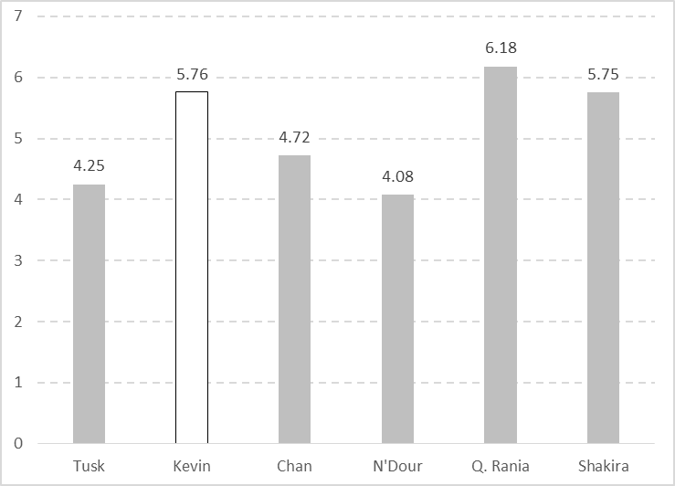

Figure 2.

Average marks for correctly described recordings.

Immediately, it is apparent that the extract which scored highest average marks was one of the NNESs, Queen Rania, not the NES (Kevin) as might have been supposed bearing in mind the bias in favour of the nativeness principle in ELT. Kevin indeed only comes in second place and gets an average score (5.76) only 0.01 higher than Shakira’s (5.75).

One suspicion is that there may be some gender bias in respondents’ scores, with female respondents being more well-disposed towards female voices: a possibility that needs investigating given that, as we say in 4.0, only 13 out of the 61 of the respondents appear to be male. In Figure 3, we compare the average scores according to whether the respondent was male or female:

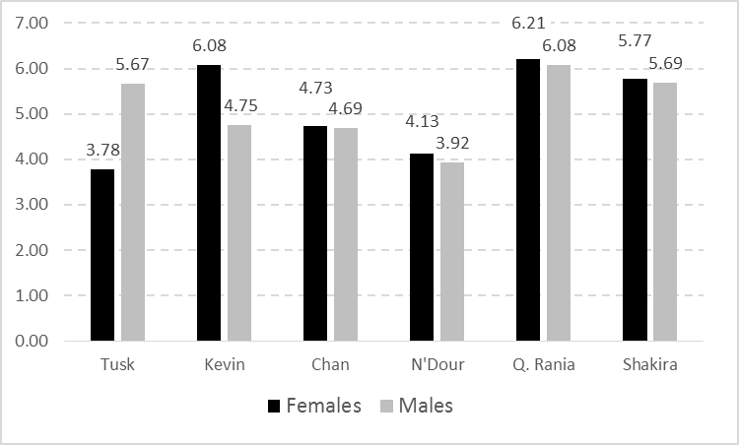

Figure 3

Average marks according to whether respondent was male or female

As can be seen, while male respondents give very slightly lower average marks to Queen Rania and Shakira than do the female respondents, they give much lower marks to Kevin (the NES): much lower in fact than Shakira (the only other female speaker), Consequently, there is no evidence for positive gender bias on the part of either group towards their own sex.

While the scores given by males and females on Figure 3 for Chan, N’Dour, Queen Rania and Shakira are similar, those for Tusk and Kevin diverge notably. The men are much better disposed towards Tusk than are the women. Indeed, they mark Tusk higher even than Kevin, who falls into fourth place: only 0.06 points above Chan. This is clear evidence that if there is a rejection of the NES model, it is more pronounced among male NNES EFL users although a sample of them is relatively small (only 13 subjects).

To measure how much agreement there is among respondents behind average scores, one can look at standard deviations (how far the marks given by individual subjects diverge on average from the mean for the whole group). In Figure 4, we give the standard deviation for each extract for the whole group:

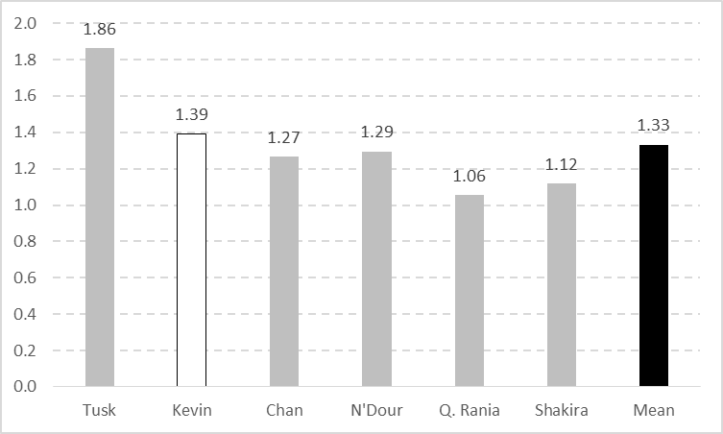

Figure 4

Standard deviation for marks given by respondents

Figure 4 shows that Tusk and Kevin are the two speakers about which there is most disagreement among respondents, by contrast, Queen Rania (closely followed by Shakira) is the one where respondents tend to give similar marks.[32] Furthermore, in the case of Queen Rania, who may be among the least well-known of the famous speakers in this survey (and indeed the title “Queen of Jordan” may not be referentially efficacious for those respondents less familiar with international affairs than with entertainment), the low standard deviation indicates not only a degree of agreement over marks but also that respondents are not in fact perplexed about who she is or whether she is NNES or not. If there were such confusion, and if respondents were going to be influenced by whether they thought she was a NES or not,[33] then the standard deviation would not have been the lowest of all.

Figure 4 indicates that there is broad agreement about the marks given to Queen Rania (and Shakira) and a degree of discord about how good Kevin’s English is. Such a clear result is remarkable as not only does it unambiguously point to the fact that respondents prefer the English of Queen Rania’s, a NNES[34], to Kevin, a NES from the inner circle, but it shows that this view is shared by most of the respondents and there is relatively little disagreement among them about it.

There is a possibility that respondents perhaps equate Queen Rania’s carefully controlled English with RP; she is speaking in a relatively formal context in a televised interview on a subject close to her heart, and something she is no doubt used to discussing in public, while Kevin gives a spontaneous unprepared reply to a question in a much more informal setting. This explanation is however thrown into doubt by the high score, and high degree of agreement among respondents, also accorded to Shakira, who, though also being interviewed for television is speaking in an informal, relaxed manner, in a context much closer to that of Kevin. Below as Examples 1-3, we produce the different transcripts so that the reader may judge this point for themselves:

1) Queen Rania

access to quality education is one of the toughest challenges . and: there are lots of online efforts in the arab world underway . er . my personal experience-my foundation last spring launched a . erm. a massive open online course . which – mooc . er. in arabic in cooperation with edex which is – as you know is a … m.i.t. . harvard . con-consortium … erm so we’re working . with: … the . best . arab . professionals . and: … er. PROFESSORS . not just in the arab world . but . arab professors also ABROAD . to really develop . erm . ori- arab cont- original . arab . con[text] . [content] . but at the same time . ALSO translating . courses from universities like harvard m.i.t berkeley etc . AND providing these courses in arabic . for free … we started off with TEN courses and we had around . eighty-five: within weeks we had eighty-five thousand er subscribers … and then . er . NOW nine months later we have twenty courses . and upwards of a hundred and forty thousand . er . subscribers-so you can see that there’s a real THIRST . to have ACCESS to this kind of information . and we’re focusing

2) Kevin

ok, i think uh … the kind of person that makes the best friend or companion . has to be somebody who’s quite superficial in the sense that i don’t i’d get bored if somebody was very heavy and . full of problems all the time … superficial in their outlook on life but at the same time …. very um, loyal … and er considerate and caring … i suppose … …. erm: … [tongue click] i can’t think of other qualities ... it would have to be somebody whose company i enjoy . probably i er somebody who more or less politically i agree with … somebody from . [a] similar background to me i imagine

3) Shakira

i was going to tell you a story er . the daughter of one of the stewardess . told me . that-her . [er] . that-that-that . yeah . i’m sorry . the stewardess told me that her little daughter . her twelve year old daughter . was . was . er . GETTING . er . the t-shirt . SIGNED . the t-shirt signed . by by the entire german team and she was . she was doing an AUCTION . because she wanted to HELP . KIDS . you know . kids who . who were SICK n and . and that was HER part of the job . and [I mean] she was completely committed . TWELVE years OLD . y’ you know . i mean when y’ you hear . stories like that . you think . things are changing . n-new generations are much more ACTIVE . than . past generations . at least in-in SOCIAL activism at least in what has to do with . you know . raising your voice for those who DON’T have a voice or who for those who are NOT listened . to . SO i feel just . that i’m a part of-of a generation that is- that is . that wants to be active- that wants to contribute somehow.

***5.2 Marks for misleadingly described recordings***

In Figure 5, as in Figure 2, we give the average scores for the speakers who were misrepresented to the respondents, including for comparison the equivalent correctly described recording.

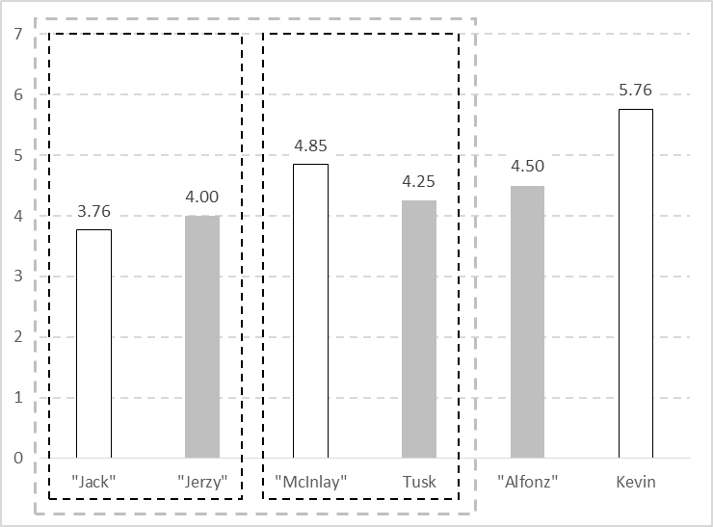

Figure 5.

Average marks for misleadingly described recordings with their correctly described counterparts

On Figure 5, a direct comparison can be made firstly between “Jack” and “Jerzy”, between “McInlay” and Tusk, and “Alfonz” and Kevin. Then one can compare the scores for “Jack” / “Jerzy” with those fro “McInlay” / Tusk as this latter adds a social distinction to the NES / NNES dichotomy.

Looking at the first level of comparison first, it can be seen how, in two out of the three pairs (“McInlay” / Tusk and “Alfonz” / Kevin), the respondents who are told the speaker is a NES give them a higher score, even when, in the case of “McInlay”, he is not. This does not happen with “Jack” / “Jerzy”; the respondents are better disposed towards the migrant than to the unemployed NES.

Comparing “Jack / Jerzy” with “McInlay / Tusk”, one can see that the former are marked lower than the latter. In actual fact, the recordings are different but are taken from the same interview. Below as Examples 4 and 5, we give the transcripts.

4) "Jerzy" / "Jack"

yeah . you know, it’s … it was …er.. really difficult time. i lost my job ….hmmm … like gorza my wife … we lost our flat … but you know in fact i’m.. i’m really lucky devil …. but an’ … but i had to start with completely new profession … i worked as . er. bread seller for one year … and …. then … i … i started with s-something completely new. i became a manual worker … working on high altitudes … you know on chimneys in factories on . on high constructions er high um. … installations and er … we painted and and rebuilt this chimneys with the use of … of . er … climbing equipment. you know six almost seven years on rope like crazy alpinist … exciting time.

5) Donald Tusk / "Stuart McInlay"

all what europe needs to today . it’s y’kn- energy . optimism . engagement … hmm.. faith … and er. … this is my specialisation. of course i’m not naïve person … no . **after being for seven years prime minister in poland[35]** i . i can’t be naïve and for sure … er … we have to do with some new challenges and and and some troubles especially that th-the condition of europe INSIDE europe … mmm: … is not so … mmm: … good . as ten or twenty years ago. as you know some people in Europe … mmm: …. are questioning our fundamental . values like freedom . the peace is threatened … mmm… because of very difficult situation in our neighbourhood in . in . in . in . in. the EAST and in . in the . the. SOUTH.

It can be seen on Figure 5 that “McInlay” and Tusk each score higher than either “Jack” or “Jerzy”. To remove the effects of the NES bias which has been identified, it is useful to compare “Jerzy” with “Tusk” and “Jack” with “McInlay” as this allows us to concentrate on the social dimension. In both cases, the speaker represented as being in a more prestigious social position is given higher marks. This tendency is higher for the NESs “Jack” and “McInlay” where there is a 1.09 point difference in the latter’s favour, than it is for the NNES, where only 0.25 points separate “Jerzy” from Tusk.[36] Furthermore, looking at the standard deviations for the marks, it emerges that in the case of speakers identified as NES, the degree of agreement between respondents is actually stronger overall and in each pair (Figure 6). Incidentally, it also indicates that respondents are in fact taken in by the misrepresentations[37] because if they were not, there would have been a greater degree of confusion manifested by a wider range of marks and more disagreement among respondents:

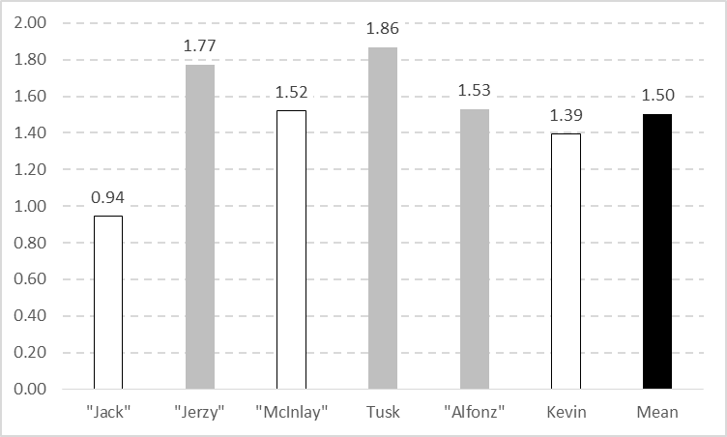

Figure 6

Standard deviation for marks given by respondents

From Figure 6, it appears that the bias towards NESs operates only when the NESs are perceived as speaking a standard and to be from a socially prestigious group. The latter tendency is seen less with NNESs. It would seem that respondents are only well-disposed to NESs who meet their expectations of what a NES should sound like. Both “Jack” and “McInlay”, because obviously they are in reality Donald Tusk, are speaking in a NNES way, which we assume respondents take for a regional or non-standard variety. If “Jack” and “McInlay” were added to Figure 2, the former, an unemployed Mancunian, would come in last place (0.32 points below N’Dour), and the latter, an elected representative from Scotland, would be fourth, 0.90 points below Shakira and only 0.13 above Jackie Chan.

In both cases, but particularly in the case of “Jack”, it would seem that NESs instead of enjoying a dividend, instead become the objects of feelings of impatience[38] (and this attitude is not restricted to a minority of respondents given that marks for “Jack” show by far the lowest standard deviation). Due to the fact that they do not live up to the expectations of a NES, not only do they have their privileges as NES withdrawn but they actually are penalised. That there is evidence indicating that such feelings may be harboured against NESs shows that, although the nativeness principle is still the conventional wisdom in mainstream ELT (see Section 1.0), learners’ support for it is not unconditional and thus their adherence to it cannot be taken for granted.

1. **Conclusions**

The survey reported in Sections 4.0 and 5.0 clearly shows that respondents may actually evaluate recordings of speakers who are described in such a way as to categorise them a NNES more highly than a recording of someone identifiably NES. If this preference can be equated with a willingness to consider as an alternative model, as seems reasonable, then it shows that the nativeness principle is not in as strong position as the air of orthodoxy which surrounds it may lead one to believe.

It is interesting that the two top scoring NNESs represent two different types of discourse (as shown by Examples 1 and 3 above), so it is not simply a question of respondents preferring a certain kind of English (i.e. something approaching one of the standards discussed in 2.0) regardless of whether the speaker producing it is actually a NES or not. However, such standards cannot be set in stone – least of all in the case of English as a global and translocal language. They would be subject to constant changes and, bearing in mind that users may accept that NNESs can speak them better than NESs (as they do in this survey), it might be these highly proficient users, rather than the NESs, who determine how they will evolve. Either way therefore, with or without accepted standards, the status of native speaker as an authority figure within English used in international contexts does not seem secure.

However as we state in Section 2.0, ELF, by its fluid nature, is not a suitable environment for standards in the sense of fixed models to emulate. Rather. It seems to require emulation of certain strategies that prove to be not only successful at helping achieve the user’s communicative goals but also versatile in that they can be adapted and used in different contexts. It is the users who perform best in such contexts, i.e. those who manage to achieve their communication goals most efficiently, who will be best placed to become role models for other users. Those experienced in ELF contexts, like the plurilingual NNES English celebrities examined here, seem to have a natural advantage over typical monolingual NESs: see Jenkins 2015:74 who argues that the most significant parameter in ELF may not be between native and non-native speakers of English but between multilingual[39] and monolingual ELF users.

One interesting result was the negative attitudes that seemed to be displayed by respondents towards NES who were perhaps thought to be speaking non-standard varieties or with non-standard pronunciation. Here the evidence that we present is obviously inconclusive, not least because the recordings were misleadingly described and the speaker in each case was an NNES, Donald Tusk. This point will have to be further investigated in another dedicated survey using authentic recordings of speakers of non-standard pronunciation and varieties of English.

Another point that emerged was the difference between marks given by respondents who, judging by the names they gave, were female and those who were male. This too will have to be the subject of future research. No doubt having more information about respondents will be useful also as regards attitudes to non-standard pronunciation and varieties of English in general as these may also depend on aspects of the respondent’s background such as social class. Another possible area to explore is the attitudes of NESs towards to ELF variations. It would be interesting to ascertain how NES respondents rated NNESs, like Queen Rania or Shakira, compared to NESs using non-standard varieties or pronunciation. The suspicion is that, like NNES respondents, they may be well disposed towards the language of those that they see as role models in other respects, regardless of the largely theoretical categorisation between NES and NNES. Such a thing is already observable in the adoption of ethnolects like MLE by speakers from the traditional NES community (see Section 3.0).

Finally, the realisation that the whole concept of standard needs revision presents a challenge to educators and policy makers. In particular, the idea that the nativeness principle and standard are one and the same, needs to be challenged (see Seidlhofer 2011). Educators and policy makers should at least question their continued adherence to the nativeness principle. It is also an invitation to be more open towards ELF variations and non-standardness of all kinds in ELT. Such a change in attitudes would mirror the movement that started in the 1960s and 70s in English teaching in English-speaking countries away from prescriptivism and towards empowering learners to manage and adapt the English language to satisfy their own needs. If we are to insist on continuing to teach learners the *Queen’s English*, we will do them a favour by at least making sure that we give them a choice of queens.

References

Bickerton, Derek. 1975. *Dynamics of a Creole System.* Cambridge: Cambridge University Press.

Blommaert, Jan. 2010. *The Sociolinguistics of Globalization*. Cambridge: Cambridge University Press.

Brutt-Griffler, Janina (2002) *World English: A Study of its Development*. Bristol: Channel View Publications / Multilingual Matters.

Burchfield, Robert, W. 1992. “The King’s English” in McArthur, Tom (Ed). *The Oxford Companion to the English Language*. Oxford: Oxford University Press.

Cheshire, Jenny / Nortier, Jacomine / Adger, David. 2015. "Emerging Multiethnolects in Europe" (PDF. *Queen Mary Occasional Papers in Linguistics*: 4)

Author, Author. 2011a. “Pronunciation and Intelligibility in ELF: A Case Study” in *Lingue e Linguaggi 6*, pp. 21-38.

2011b. ““Fluency and Pronunciation in the Assessment of Grammatical Accuracy in Spoken Production: An Empirical Study” *Lingue e Linguaggi* 6, pp. 7-20

2014. “Putting the accent on intelligibility: What constitutes “good” pronunciation in the context of English as a lingua franca? A case study of learners of different L1s.” in *Textus XXVII n. 1 –*2014 *(Language Issue), Perspectives on* English *as a Lingua Franca*, Guido, M.G. / Seidlhofer, B. (Eds.)*,* pp.35-51.

2015. “Anaphora in question-answer sessions in university ELF contexts.” in *Lingue e Linguaggi* 13. pp. 87-105.

(2017) “How far do ordinary speakers of other languages show ELF-oriented as opposed to native speaker-norm oriented attitudes to learning English.” in *Lingue e Linguaggi* 21, pp. 57-77.

The Council of Europe. 2001. *The Common European Framework of Reference for Languages: learning, teaching, assessment*, Cambridge, Cambridge University Press.

Coyle, Do / Hood, Philip / Marsh, David. 2010. *CLIL: Content and Language Integrated Learning*. Cambridge: Cambridge University Press.

Crystal, David. 2003. *English as a Global Language*. Cambridge: Cambridge University Press.

Graddol, David. 2010. *English Next*. London: The British Council.

Harrington, J. / Palethorpe, S./ and Watson, C. 2000. “Does the Queen speak the Queen's English?” in *Nature*, 408, pp. 927-928.

The International Phonetic Association. 1999. *Handbook of the International Phonetic Association: A guide to the use of the International Phonetic Alphabet*, Cambridge: Cambridge University Press.

Jenkins, Jennifer. 1998. “Which pronunciation norms and models for English as an International Language?” *ELT Journal*, 52/2: 119-126.

(2000) *The Phonology of English as an International Language*, Oxford, Oxford University Press.

(2007) *English as a Lingua Franca: Attitude and Identity*, Oxford, Oxford University Press.

(2015) “Repositioning English and multilingualism in English as a Lingua Franca” in *Englishes in Practice*, 2(3), pp. 49-85

Kachru, Braj B. 1985. “Standards, codification and sociolinguistic realism: the English language in the outer circle.” In R. Quirk, R. / Widdowson, H.G. (Eds.), *English in the World: Teaching and Learning the Language and Literatures*. Cambridge: Cambridge University Press, pp. 11-30.

(2005) *Asian Englishes: beyond the canon*, Hong Kong, Hong Kong University Press.

Labov, William. 1969. *The Study of Nonstandard English*, Washington DC: The National Council of Teachers of English.

Labov, William / Ash, Sharon / Boberg, Charles 2006. *Atlas of North American English: Phonology and Phonetics*. Berlin: Mouton/de Gruyter.

Levis, John, M. 2005. “Changing contexts and shifting paradigms in pronunciation teaching,” in *TESOL Quarterly*, 39, pp. 369-377.

McWhorter, John. 2007. *Language Interrupted: Signs of Non-Native Acquisition in Standard Language Grammars*. New York:Oxford University Press.

Ogden, Charles, Kay. 1930. *Basic English: A General Introduction with Rules and Grammar*, London: Paul Treber.

Ostler, Nicholas. 2010. *The Last Lingua Franca: English until the Return of Babel*. London: Penguin.

Pearce, Michael. 2007. *Routledge Dictionary of English Language Studies*. London: Routledge.

Pennycook, Alastair. 2007. *Global Englishes and Transcultural Flows*. London: Routledge.

Quirk, Randolph (1985). “The English language in a global context.” In R. Quirk, R. / Widdowson, H.G. (Eds.), *English in the World: Teaching and Learning the Language and Literatures*. Cambridge: Cambridge University Press, pp. 1-6

Rosewarne, D. 1994. “Estuary English: tomorrow’s RP?” *English Today* 37 v 10 (1) January 1994 pp 3-9.

Seidlhofer, Barbara (2011): *Understanding English as Lingua Franca*, Oxford: Oxford University Press.

Trudgill, Peter. 1980. *The Social Differentiation of English in Norwich*, Cambridge: Cambridge University Press.

Trudgill, Peter / Hannah, Jean (2002) *International English: A Guide to the Varieties of Standard English*, 4th ed. London: Arnold

Van Riper, William R. 1986. “General American: An Ambiguity”, in Allen, Harold B.; Linn, Michael D., *Dialect and Language Variation*, San Diego: Academic Press / Harcourt Brace Jovanovich, pp. 123-135.

Wells, John C. 1982. *Accents of English*, 1, Cambridge: Cambridge University Press.

Widdowson, Henry. 2015. “ELF and the pragmatics of language variation.” In *Journal of English as a Lingua Franca*, 4(2), pp 359–372.

1. Author (2017). This forms a companion to this present article as both originally formed part of a paper read at the ELF9 conference in Lleda, June 2016, entitled “Can the prestige gap between ELF and standard varieties of English ever be narrowed? Can “ELFness” ever replace the Nativeness Principle in the hearts of learners of English?
2. “English is a translocal language, a language of fluidity and fixity that moves across, while becoming embedded in, the materiality of localities and social relations. English is bound up with transcultural flows, a language of imagined communities and refashioning identities” (Pennycook 2007: 5-6).
3. See Coyle *et al* (2010)
4. The CEFR is currently being revised and trials are being made with new descriptors which do not use the term native speaker.
5. The oft-cited definition of Trudgill and Hannah (2002: 1) of Standard English is simplistic: “[…] the variety of the English language which is normally employed in writing and normally spoken by ‘educated’ speakers of the language.” This rests on the undefined notion of ‘educated’ and is also circular in that someone may be considered ‘educated’ precisely because they use something identified as Standard English (see Seidlhofer 2011).
6. Contrast this with, for example, Quirk (1985: 6) “The relatively narrow range of purposes for which the non-native needs to use English (even in ESL countries) is arguably well-catered for by a single monochrome standard that looks as good on paper as it sounds in speech. There are only the most dubious advantages in exposing the learner to a great variety of usage, no part of which he will have time to master properly, little of which he will be called upon to exercise, all of which is embedded in a controversial sociolinguistic matrix he cannot be expected to understand.”
7. Brutt-Griffler (2002) uses the term *macroacquisition* or *social SLA* (second language acquisition) to describe the situation where multilingual speech communities come about through the community *en masse* acquiring a second or foreign language.
8. In essence, McWhorter’s argument rests on the observation that it is the languages spoken by smaller isolated communities that are consistently linguistically more complex than those used by larger more dispersed communities which consequently have greater contact with other communities.
9. In the case of the UK the struggle to find a suitable term for the “standard” is indicative of the underlying complexity of that which such a term is intended to describe. Daniel Jones, the father of RP, originally chose the term *Standard Pronuniciation* (StP), but dropped it due the implication that other varieties were unorthodox. After that, he used for a while *Public School* *Pronunciation* (PSP). Finally, he rather reluctantly settled for the adjective *received*: an epithet that had been used by some 18th and 19th century linguists. *The Handbook of the International Phonetic Association* (1999) has adopted the name “Standard Southern British” for RP, which, while no doubt accurate, adds the same regional dimension that Jones had striven so hard to avoid.
10. The British comedians Alexander Armstrong and Ben Miller are famous for their WWII pilot sketches, the humour of which mostly lies in the spectacle and incongruity of two upper class RAF officers speaking Multicultural London English (see Section 3.0) in RP accents.
11. The BBC (British Broadcasting Company) was originally set up by British and US electrical companies in 1922 with John Reith as its managing director. It was a commercial operation designed to increase sales of radio sets. In 1926, it was transformed into the crown-chartered British Broadcasting Corporation, still with Reith as Director General, and given a monopoly of broadcasting in the UK.
12. Another term which is heard is *The* *Queen’s* / *King’s English*. This dates back to the Fowler brothers’ usage manual of 1906 (see Burchfield 1992: 561). Its use in the context of a comparison between NES models and ELF is ironic precisely because so many of England’s monarchs have been NNES or at least plurilingual.
13. Wells (1982: 34) puts the figure as high as two-thirds, although more recently, and using more sophisticated measures, Labov *et al* (2006) show that regional variation in the USA is in fact increasing.
14. That US English or British English may have certain important non-standard varieties is nothing special in itself; the same may be said of other cases (e.g. Neapolitan for Italian, Provençal for French, or Berlinerisch for German), and average L2 learners of these languages are not expected to have a knowledge of these. However, in the particular case of English as a translocal language, certain linguistic varieties may be associated with specific linguistic or artistic genres and thus have relevance for learners: for example, AAVE with Hip Hop, R&B, Rap etc. – all highly popular forms of music right across the world. Similarly, in popular and rock music, lyrics are typically in a *kunstspracht* (art language) that owes its origins to Southern US English (Ostler 2010: 58).
15. Indeed, in the early 1970s it was estimated that only 3% of the general population used it (Trudgill 1980).
16. Reported on the British Library website:

    http://www.bl.uk/learning/langlit/sounds/find-out-more/received-pronunciation/ (accessed 25/08/16)
17. Indeed studies of Queen Elizabeth’s annual Christmas Message show how her distinctive version of RP pronunciation has changed over her long reign (see, for example, Harrington *et al* 2000), perhaps partly by design in an attempt to sound less distant from her subjects.
18. In Creole studies, a continuum has been described between the basilect (the creole furthest from the standard) and the acrolect (the version of the creole closest to the standard) with a mesolect in between (see Bickerton 1975). This is a relevant model for description of the relationship between standard and non-standard varieties in general.
19. In its British use, this term means someone especially in the popular entertainment industry incorporating features of US English in their language possibly as an alternative to RP: a phenomenon that is less common today as British regional varieties have become more acceptable and prestigious. In the USA, the terms *Mid-Atlantic* or *Trans-Atlantic English* as well as, confusingly, *Standard American* have been used for essentially the same phenomenon in reverse: US English with affected RP features. This is found particularly in early Hollywood films.
20. Widdowson (2015: 363). “Variety status is achieved when variations become conventionalized and so settle into what is taken to be a systematic state, in other words, when variation is taken to be regularized to the extent that it constitutes language change.”
21. This is the same objection that is made about judging speakers using non-standard varieties of English, like AAVE, against standards. This was a mistake made by many educationists, famously exposed by Labov (1969).
22. Interestingly, in 1941, the BBC took the unusual step of drafting in Wilfred Pickles from its regional service to read the national news even though he had a distinctive Yorkshire accent. Unsurprisingly, he proved a controversial choice (he would apparently depart from the script, signing off with his catchphrase “and to all in the North, good neet") but went on to have a long and highly successful career. At the time, it was said that he was chosen to thwart Nazi propagandists’ attempts to impersonate BBC announcers. Whatever the truth of this explanation, it is certainly relevant to note how the BBC opted for the voice of a common man, while the Nazis used announcers, like William Joyce, with their affected upper class RPs. It is revealing that Joyce *et al* collectively quickly earned the nickname “Lord Haw-Haw” as if they were a single person. One may speculate that the BBC choose an announcer using a non-standard, less prestigious, variety also because he displayed more individuality and sounded more genuine, sincere and credible.
23. In his short discussion of this point, Graddol gives the impression that this revision of the three circles model is the work of Kachru but gives no precise reference. In fact, it would seem to be his own application to speakers of Kachru’s (1998) concept of *functional nativeness* originally used to describe the relationship of languages to the area in which they are spoken. That said, one may assume that Graddol’s conclusions are in tune with Kachru’s views on the matter: “it is obvious that the cross-cultural and localized functions of Englishes have now made the dichotomy of native versus non-native theoretically and functionally questionable” (Kachru 2005: 210).
24. It should perhaps be underlined that the proponents of the intelligibility principle do not advocate the deliberate engineering of English (on the lines of *Basic English,* Ogden1930) to make it simpler or more NNES-friendly. They should be products of the same processes that lead to ELF variations.
25. Pearce (2007: 146): “Social and linguistic prestige is interrelated. The language of powerful social groups usually carries linguistic prestige; and social prestige is often granted to speakers of prestige languages and varieties.”
26. This constitutes a process which also involves elements from adult learners of English and must resemble that which McWhorter (2007) speculates happened in Old English to bring about the fundamental changes to English syntax (e.g.”meaningless do” in questions and negatives etc, and the progression construction *be + ing* which McWhorter argues may come from native Celtic languages) that are only recorded in writing centuries later and have been perhaps erroneously labelled as Middle English.
27. moodlecloud.com. The survey itself can be found at https://englishsurvey.moodlecloud.com
28. As well as anonymous friends of friends, we should like to thank the following for their invaluable cooperation in finding subjects: Adriana Cattell Maiorano (LIceo Arisstosseno, Taranto Italy); Nalan Kiziltan (Ondokuz Mayis University, Turkey); Joanna Radwanowicz (University of Bialystok, Poland); Genci Shurdho and Suela Ceka (*Yes* schools group, Albania), and the English teachers at the Berufsbildende Schule Bernkastel-Kues, Germany.
29. We were lucky in that there were no cases of names that could be either male or female (e.g. Andrea or Nicola, in Italy)
30. Here, as elsewhere in this paper, we give figures to two decimal places.
31. It is possible that the original video extracts would have been more effective, but there were restrictions on the size of file that we could use.
32. It may be suspected that the different size of the samples may be an issue here, the standard deviation may be increased because both Tusk and Kevin were marked by fewer respondents, as we note in Section 5.0. In fact, if we take the twelve respondents who were presented with Tusk and look at the standard deviation of the scores that they gave to Queen Rania, her figure is even lower (not larger), 0.98, than that given on Figure 4 (1.06), so this doubt is removed.
33. Indeed, another interpretation is that there was confusion over whether she was a NES or not but this had no effect on marks. If this were so, it would actually indicate the proposition that the nativeness principle has lost all relevance for learners. In fact, the results reported in 5.2 show that respondents will give different marks to the same extract depending on whether they are led to believe that the speaker is NES or not.
34. Queen Rania, who has Palestinian heritage, was born in Kuwait but was educated in English and went to the American University in Cairo. She would not qualify as an inner circle speaker on Kachru’s original model (1985) but could easily be included in the highly proficient group of users in the inner circle of Graddol’s revision (2010: 110).
35. This part of the extract (in bold) was, for obvious reasons, edited out of the recording identified as Stuart McInlay.
36. On the point of how perceived social prestige affects marks, it might be argued that Queen Rania comes out top precisely because she is described as “Queen of Jordan”. However, this would fail to explain, barring a bias towards monarchism in our sample, why Donald Tusk, identified as “President of the European Council and former Prime Minister of Poland”, comes in only second from last place.
37. In fact, we had assumed that the subterfuge would be successful. In earlier research (Author 2011a), it clearly emerges that respondents like these cannot reliably identify NESs or the L1 of speakers unless they are familiar with features of this particular L1 (e.g. if they share it) and the speaker has a strong L1 accent.
38. And it is not beyond the realms of imagination that many learners of English who have dedicated hours, and possibly a lot of money, to learn English may harbour traces of jealousy towards those who are born into it and enjoy a privileged position. Such suppressed resentment may bubble up to the surface in the case of those (like unemployed “Jack”) who speak a barely intelligible non-standard form.
39. Jenkins (2015 74-75) argues against use of the term *plurilingual*, preferring instead *multilingual*. The CEFR (Council of Europe 2001: 4-5) uses both, reserving *plurilingualism* to refer specifically to the ability of the individual speaker to manage communication in different languages, and within different cultural contexts.